
Replayer
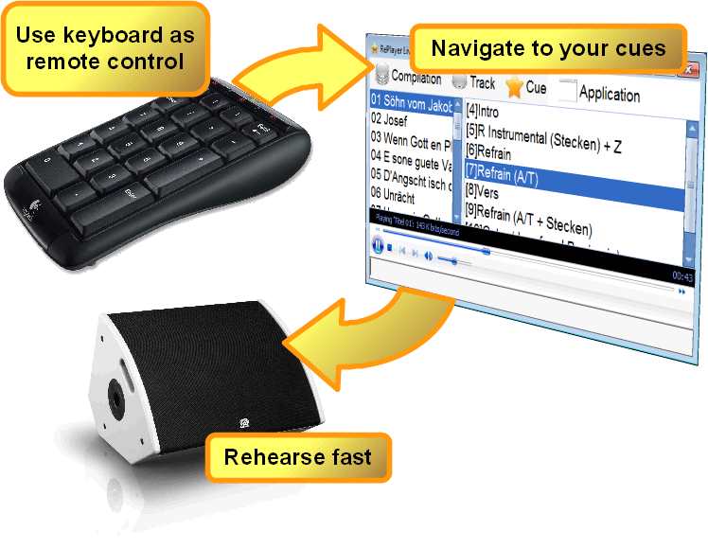
Replayer is a free media player for use during rehearsals with playback music. It's main feature is fast navigation to predefined cue points in the playback media.

Getting started...
First, you create a compilation of tracks and cues once, using a wizard. Then, using Replayer and your laptop computer, you can rehearse any portion of your set with ease.
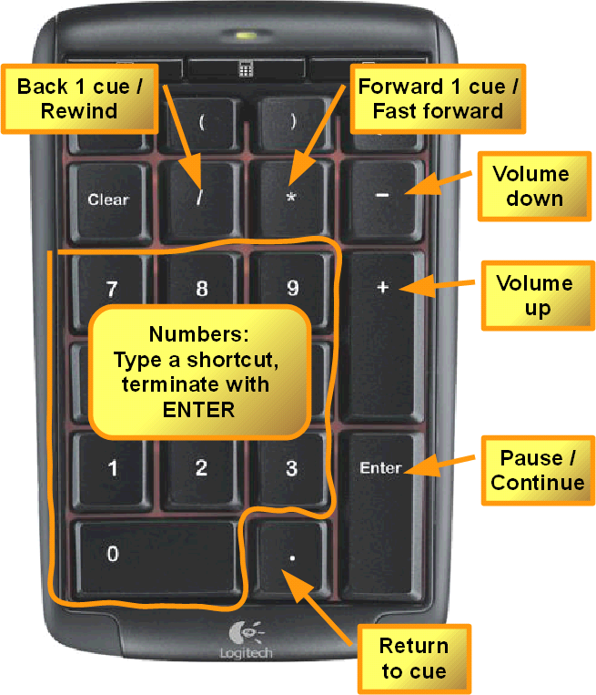
Use the navigation features on the numeric keypad.

Get your free copy from http://replayer.codeministry.ch

